[**WORKING WITH THE DATASET**](https://careereducation.smartinternz.com/Student/guided_project_workspace/10708#collapse1)

**Loading the Dataset**

Open Cognos Analytics and click upload data

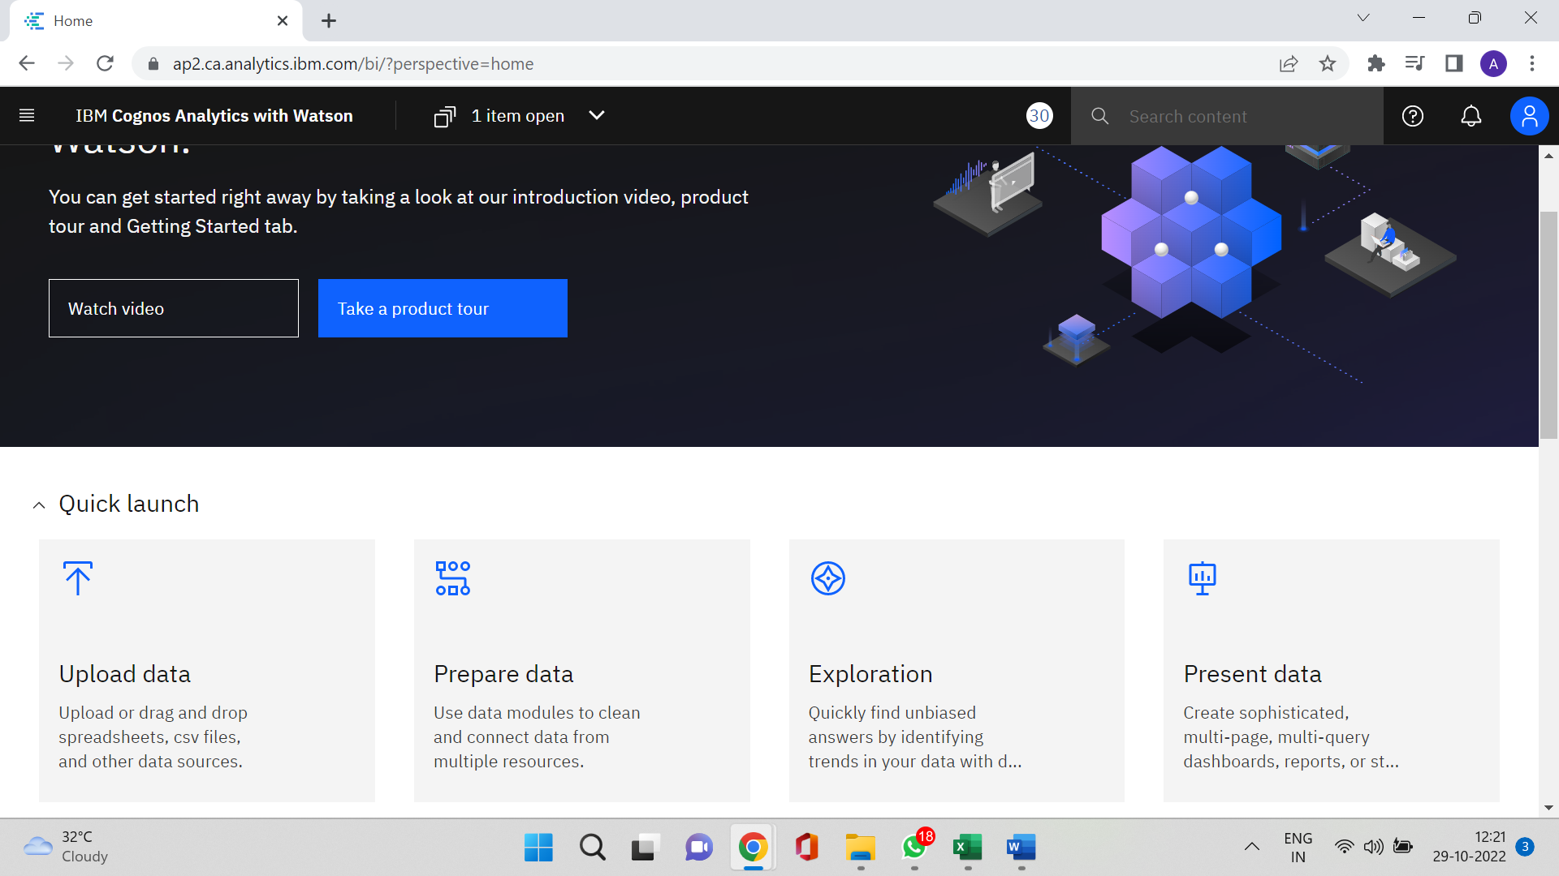

Select the dataset to be uploaded

The excel file is getting uploaded in Cognos Analytics

The dataset can be accessed in My Content in Cognos Analytics

